Conference Report: M.A. Rangoonwala College Shines at the 12th Annual MSC-AOMSI Conference
Date: 5th – 7th February 2026
Location: Latur, Maharashtra
Event: 12th Annual Conference of the Maharashtra State Chapter of AOMSI (MSC-AOMSI)
The Department of Oral and Maxillofacial Surgery at M.A. Rangoonwala College of Dental Sciences and Research Centre proudly marked its presence at the 12th Annual Conference of the Maharashtra State Chapter of the Association of Oral and Maxillofacial Surgeons of India (MSC-AOMSI).
Held in Latur from February 5th to 7th, 2026, the conference was a convergence of knowledge, skill, and fraternity. The event featured insightful lectures, advanced case discussions, and a celebration of the evolving landscape of Maxillofacial Surgery.
The college was represented by a robust delegation of 15 members, comprising:
- 3 Faculty Members
- 12 Postgraduate Students
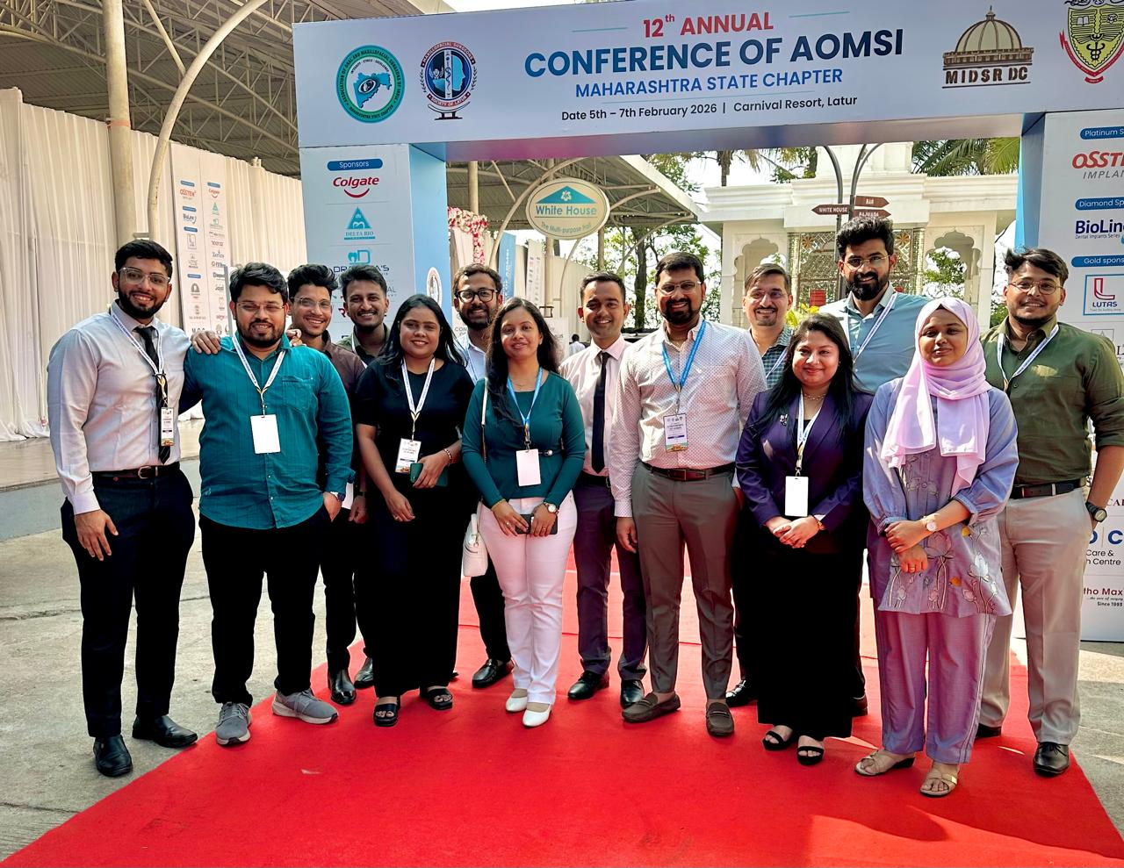
The team actively participated in scientific sessions, pre-conference courses, and skill-based competitions, showcasing the department's commitment to academic and clinical excellence.

Faculty Contributions
Our esteemed faculty members played pivotal roles in the scientific deliberations, contributing their expertise to the forum:

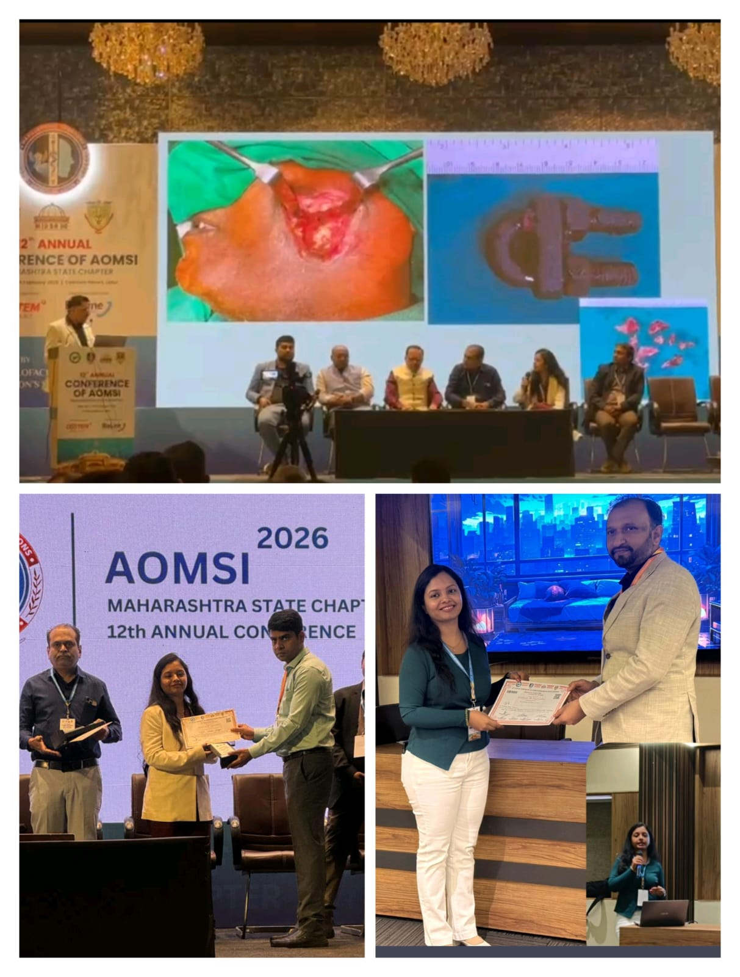

Dr. Sneha Setiya: Served as a distinguished Panellist for the Panel Discussion on Maxillofacial Trauma. Additionally, she presented a paper in the Delegate Prize Category, contributing valuable insights to the field.
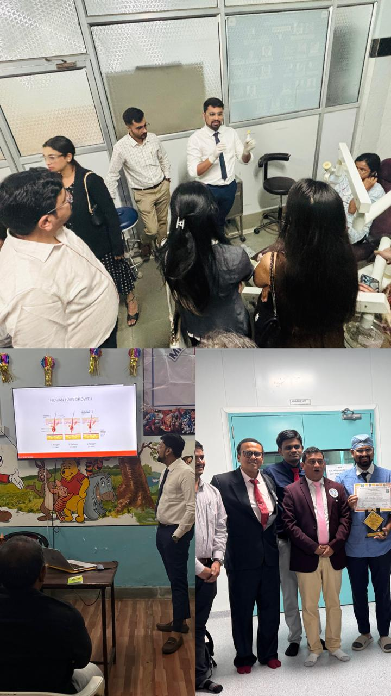

Dr. Shubham Katariya: Invited as Faculty for the Pre-Conference Course on Hair Transplant, sharing advanced techniques and knowledge with delegates.

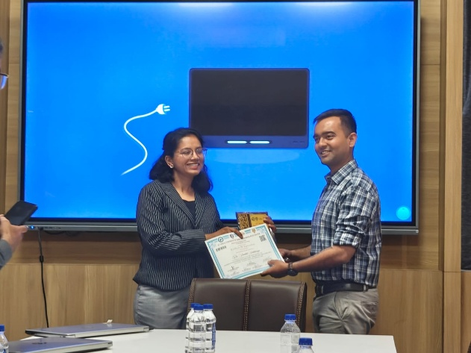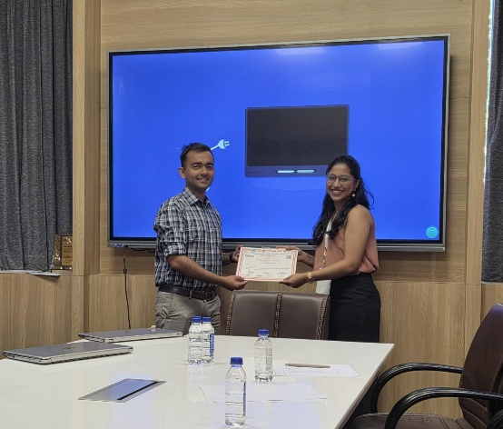

Dr. Samkit Sakhariya: Honoured as the Chairperson for the Postgraduate Paper Presentation session, guiding and evaluating the next generation of surgeons.

Postgraduate Achievements and Accolades
The postgraduate students of the department displayed exceptional skill and academic acumen, bringing home multiple laurels across various scientific categories and skill competitions:
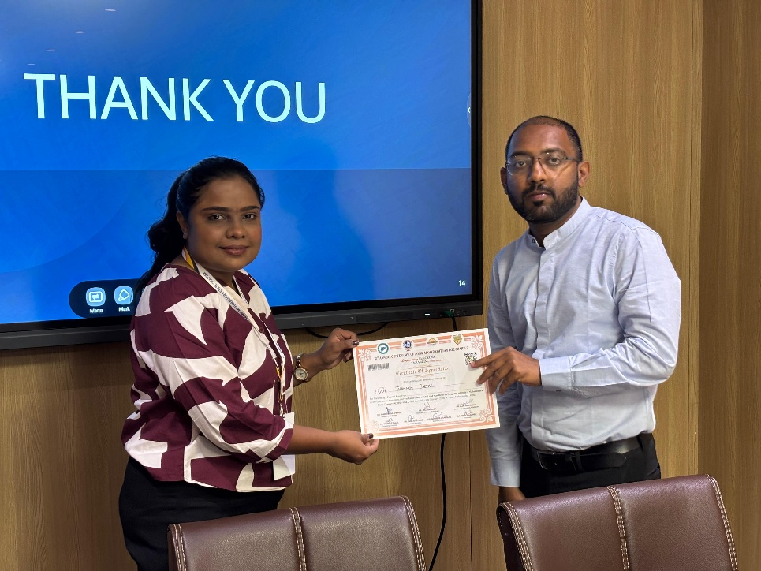
Dr. Tarannum (3rd Year Post Graduate): Secured Best Session Paper in the Scientific Paper Presentation category.
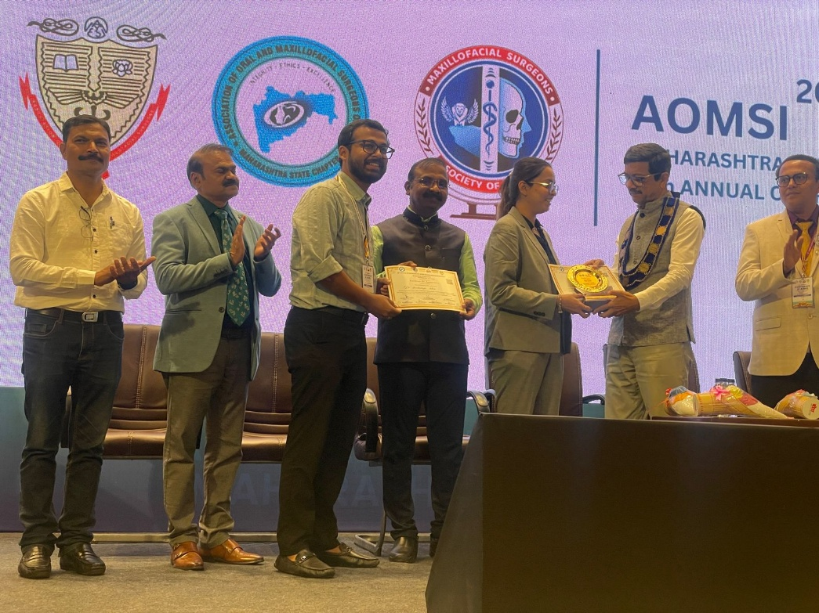
Dr. Shrishailya (3rd Year Post Graduate): Won Second Prize in the Skill Competition for Intermaxillary Fixation (IMF) Wiring Techniques.
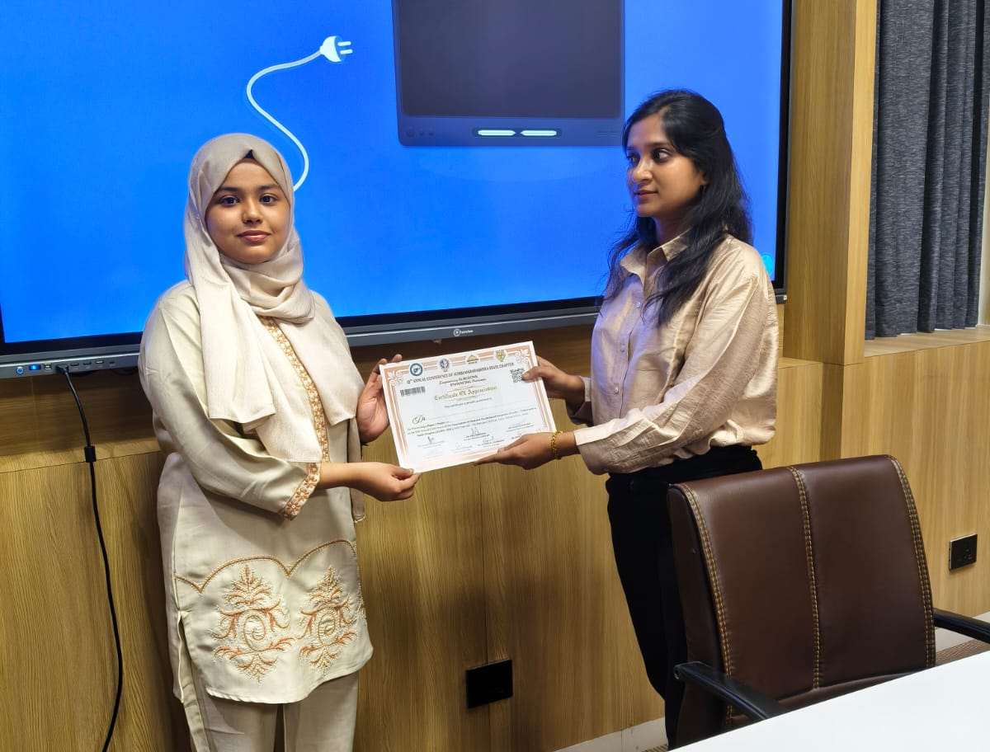
Dr. Abida (2nd Year Post Graduate): Awarded First Prize in the Skill Competition for Suturing Techniques in OMFS.
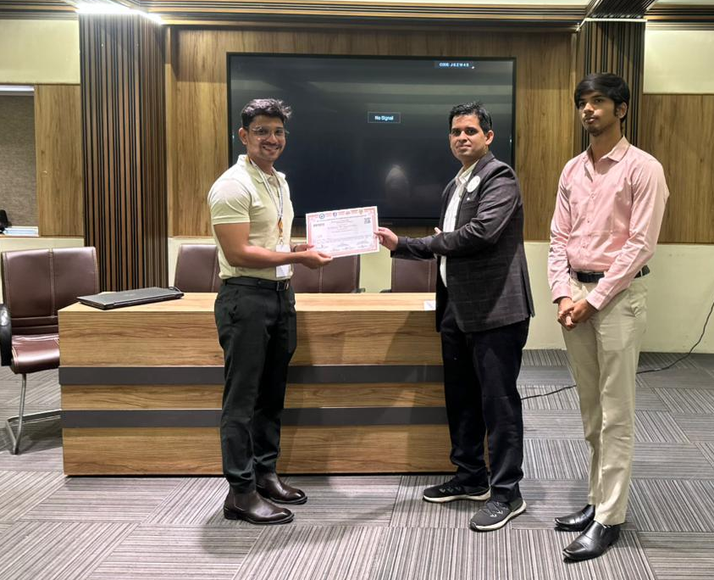
Dr. Imran (2nd Year Post Graduate): Received Second Prize in the Poster Presentation Competition.

Conclusion
The 12th Annual MSC-AOMSI Conference was a truly enriching experience for the department. The active participation of our faculty and the winning streak of our postgraduates reflect the high standards of training and education at M.A. Rangoonwala College of Dental Sciences and Research Centre. We look forward to continuing this tradition of excellence in future academic forums.

